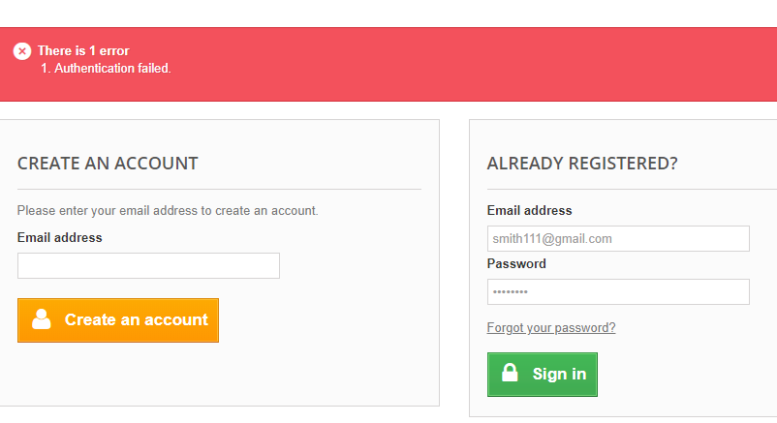

This test case passed because the user Email address or password doesn’t exit **(invalid email address)**

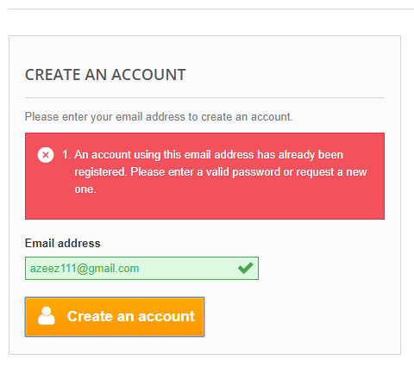

This test case passed because the email address has already been registered, to create an account new email address needed.

Note: To check if the ***create an account*** working email address on the source code need to be change to new email.